IS IT A VERMEER?
Heading on paper. Title it “Is it a Vermeer?” Based on what you know of Vermeer’s style, write a paragraph that uses 2 reasons to explain which of these is likely NOT a Vermeer and why. Use specific evidence from the photos.
A
B
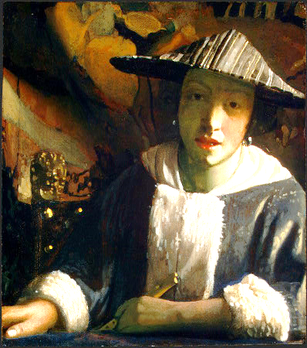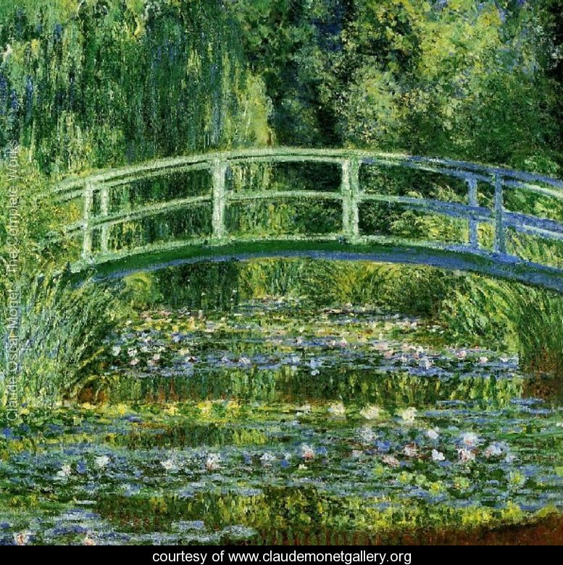

2. Based on what you know of Vermeer’s style, write a paragraph that uses 2 reasons to explain which of these IS LIKELY A VERMEER and why. Use specific evidence from the photos.

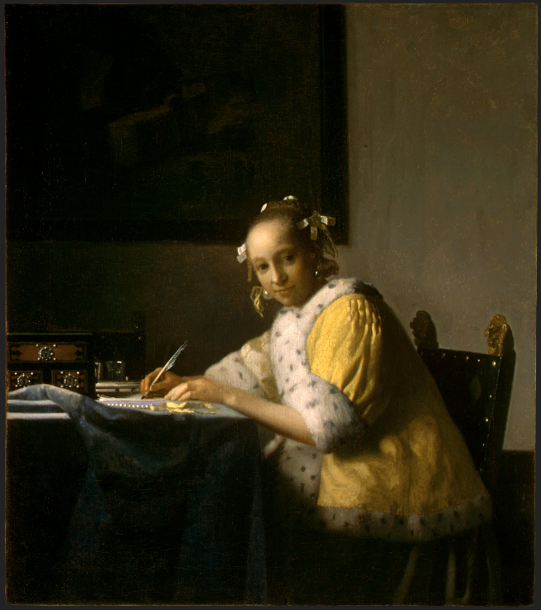
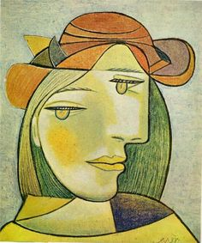
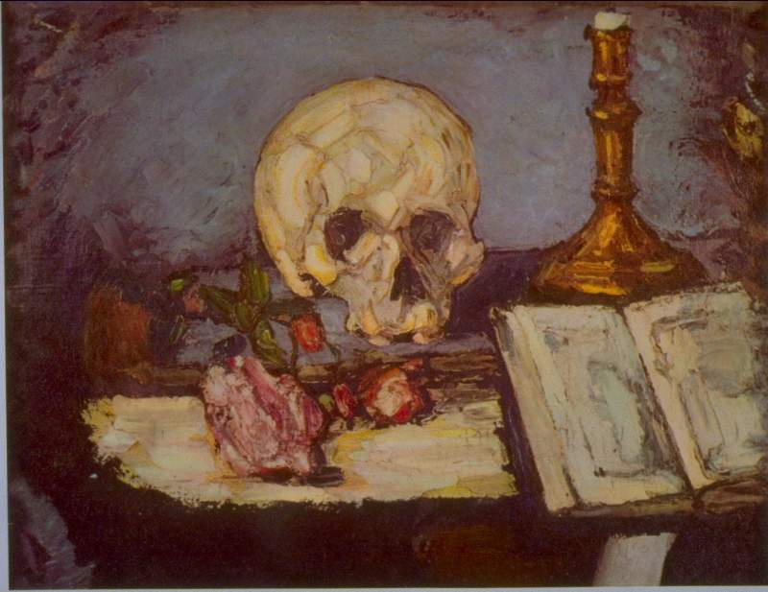
C
B
A

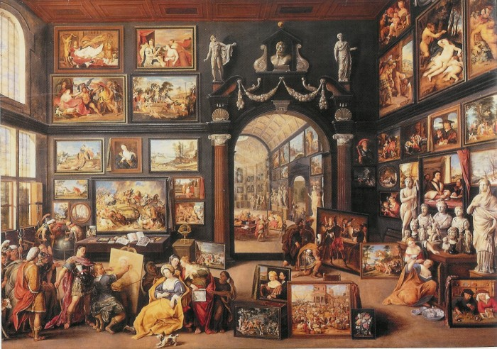
D
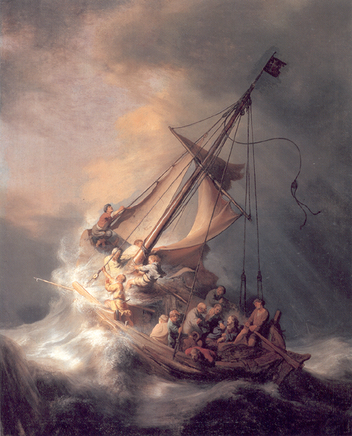
E

